
University of Frontier Technology, Bangladesh
Department of Internet of Things and Robotics Engineering

Course Code | CC 483
Course Title | Cloud Computing

LAB REPORT
Lab 10: Cloud Infrastructure, High Availability & Observability on Azure
Network Isolation, Load Balancing & Cost Governance on Microsoft Azure

Submitted To
Farzana Akter
Assistant Professor
Department of Internet of Things and Robotics Engineering
University of Frontier Technology, Bangladesh
Submitted By
Sl | Class Roll | Name | Session
01 | 2201022 | Mst. Esat Jahan Akhi | 2022-2023

Date of Submission
August 6, 2026

Executive Summary
This lab focuses on architecting and deploying a secure, high-performing, and cost-efficient cloud environment on Microsoft Azure. The overall design addresses three major enterprise requirements:
- Network Security & Isolation (Task 1): Deploying application and database tiers inside segregated private subnets using Network Security Groups (NSGs) to prevent direct public internet exposure to sensitive data.
- Scalability & High Availability (Task 2): Distributing web traffic across multiple application instances via an Azure Load Balancer with active Health Probes to ensure seamless continuity during virtual machine (VM) failures.
- Observability & Cost Governance (Task 3): Implementing real-time monitoring through Azure Monitor, configuring automated metric-based alerts, and establishing budget limits to prevent cloud overspending.

Resource Group | Lab10-RG
Subscription | Azure for Students

Task 1: Secure Network & Private Database Deployment

1.1 Architectural Overview
A custom Virtual Network (Lab10-VNet) was provisioned to establish strict network boundaries. The topology divides the network space into two distinct private subnets:
- AppSubnet: Hosts application servers (App-VM and App-VM2).
- DBSubnet: Dedicated solely to the database server (DB-VM).

1.2 Security Configuration (NSG Rules)
Network Security Groups were created and associated with their respective subnets:
AppNSG (Application Subnet)
- Allowed inbound HTTP (Port 80) and HTTPS (Port 443) traffic to serve application requests.
DBNSG (Database Subnet)
- Allowed inbound database traffic (e.g., Port 1433/3306) only originating from the AppSubnet IP range (10.0.1.0/24).
- Denied all direct public inbound connections from external IP addresses.

1.3 Connectivity & Security Verification
Public Access Attempt to DB | Attempts to connect directly to DB-VM via external public IPs failed as expected, confirming effective perimeter protection.
App-to-DB Communication | Internal communication between App-VM (10.0.1.4) and DB-VM (10.0.1.5) succeeded over private IPs, confirming proper cross-subnet routing.

Task 2: Scalability & High Availability Configuration

2.1 Load Balancer & Backend Topology
To eliminate single points of failure, an Azure Standard Load Balancer (Lab10-LB) was deployed in front of the application layer.
- Frontend IP: Configured with a Public IP (40.80.76.113 / LB-Frontend-IP).
- Backend Pool (App-Backend-Pool): Contains App-VM (10.0.1.5) and App-VM2 (10.0.1.4).
- Health Probe (HTTP-Probe): Monitored backend instance status via TCP Port 80 at 5-second intervals.
- Load Balancing Rule (HTTP-Rule): Routed incoming port 80 frontend traffic evenly across healthy backend pool instances.

2.2 Configuration Evidence
Backend pool configuration showing App-VM and App-VM2:
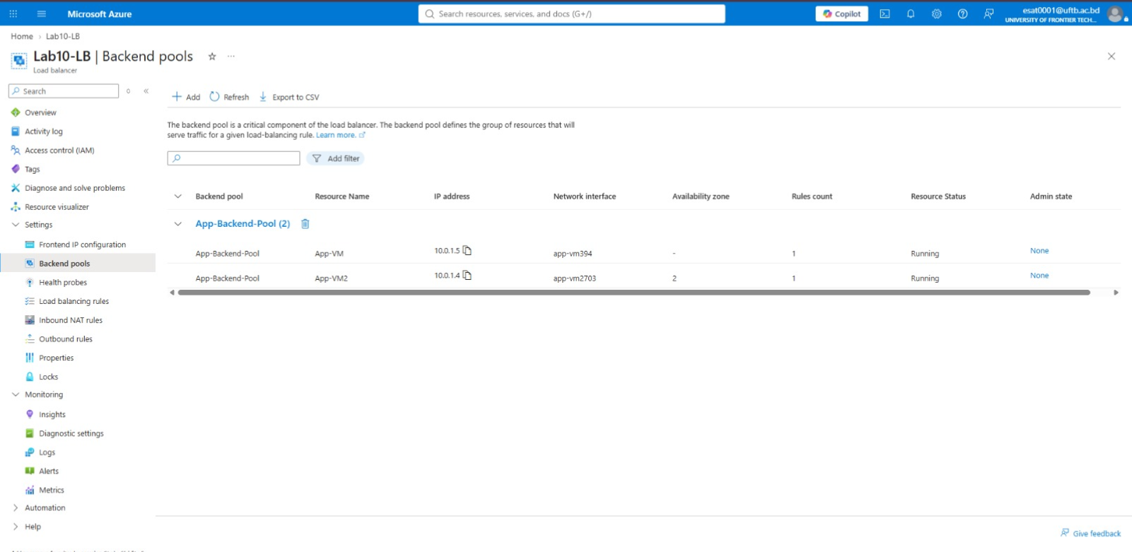
Health probe settings for HTTP-Probe:
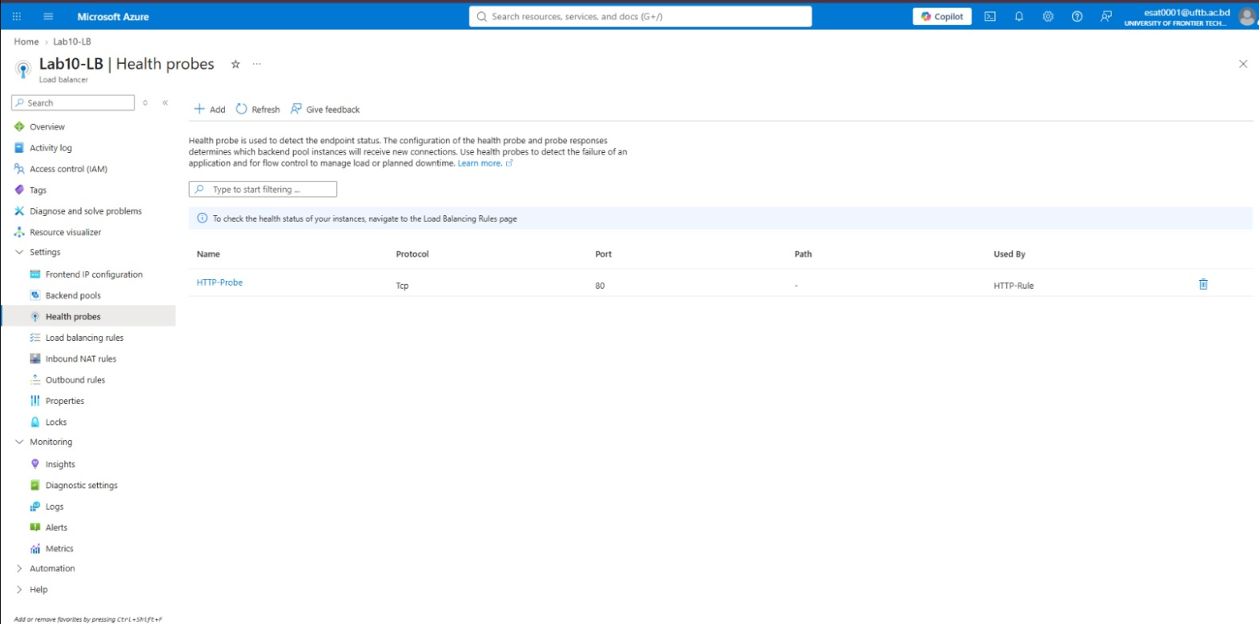

2.3 Failure Simulation & Traffic Failover Analysis
Simulation Procedure
- Both App-VM and App-VM2 were initially added to App-Backend-Pool.
- A manual failure was simulated by initiating a Stop (Deallocate) command on App-VM2 via the Azure Portal.
- The Load Balancer's HTTP-Probe continuously evaluated the host condition.
Observations & Results
- Upon stopping App-VM2, the health probe detected consecutive failed responses and flagged the instance as unhealthy/down.
- Traffic routing automatically adapted, directing all incoming user requests exclusively to the remaining healthy node (App-VM).
- Application access remained continuous with zero downtime reported from the end-user perspective.

Load Balancer metrics showing health probe status graph:
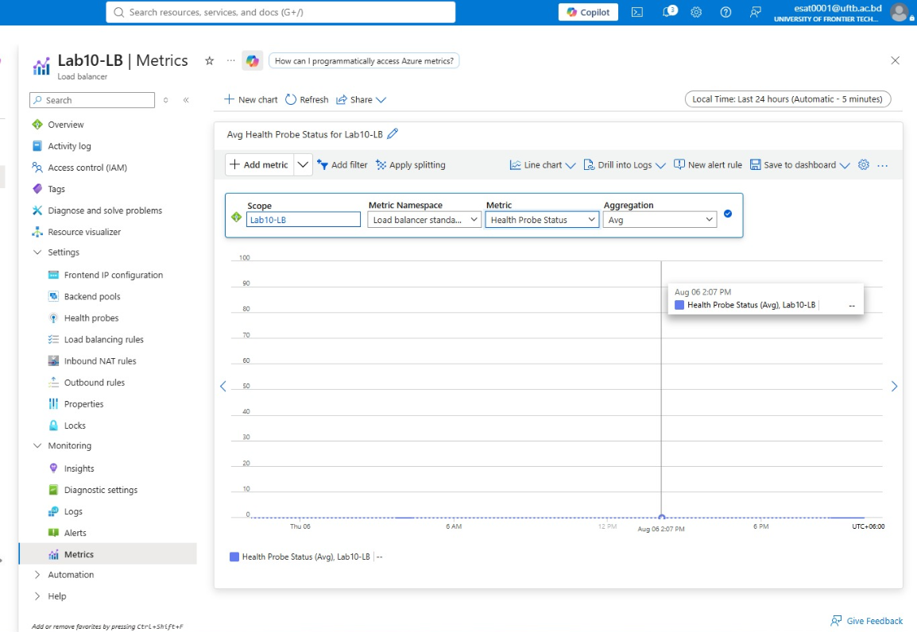
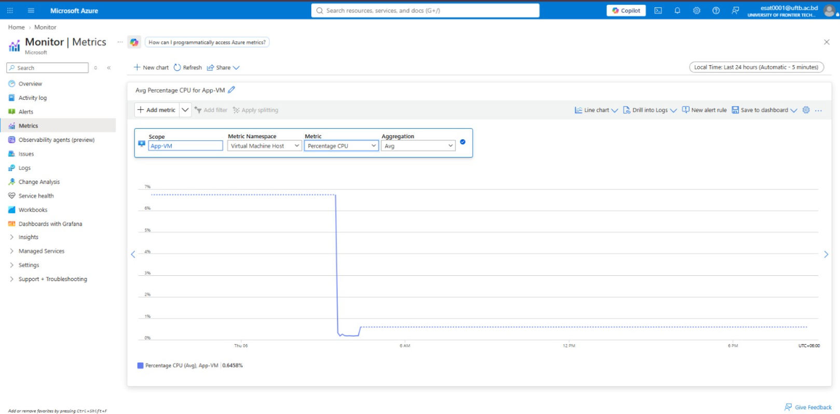
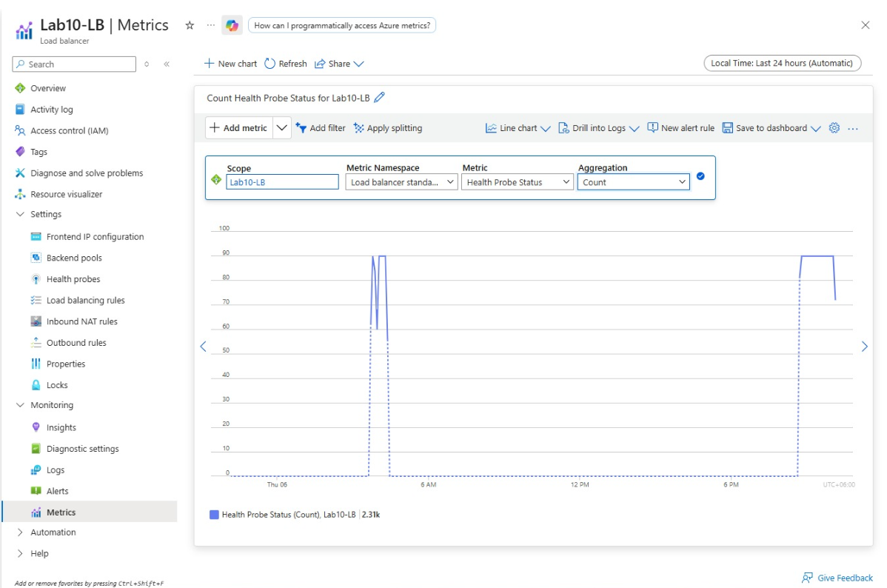

Task 3: Observability & Cost Analysis

3.1 Azure Monitor & Metrics Analysis
Real-time monitoring was enabled across all deployed virtual machines and network resources. Key performance metrics were tracked:
- Percentage CPU: Monitored compute load on application nodes.
- Network In/Out: Evaluated throughput across the Load Balancer and VM interfaces.
- Health Probe Status: Tracked active availability counts.

3.2 High CPU Alert Rule Setup
To ensure proactive incident management, an automated alert rule was configured:
Target Resource | App-VM
Signal Condition | Percentage CPU > 80%
Action Group | NotifyAdmin (Global scope, Display Name: NotifyAdmin)
Notification Mechanism | Email alert dispatched to administrator upon threshold breach.

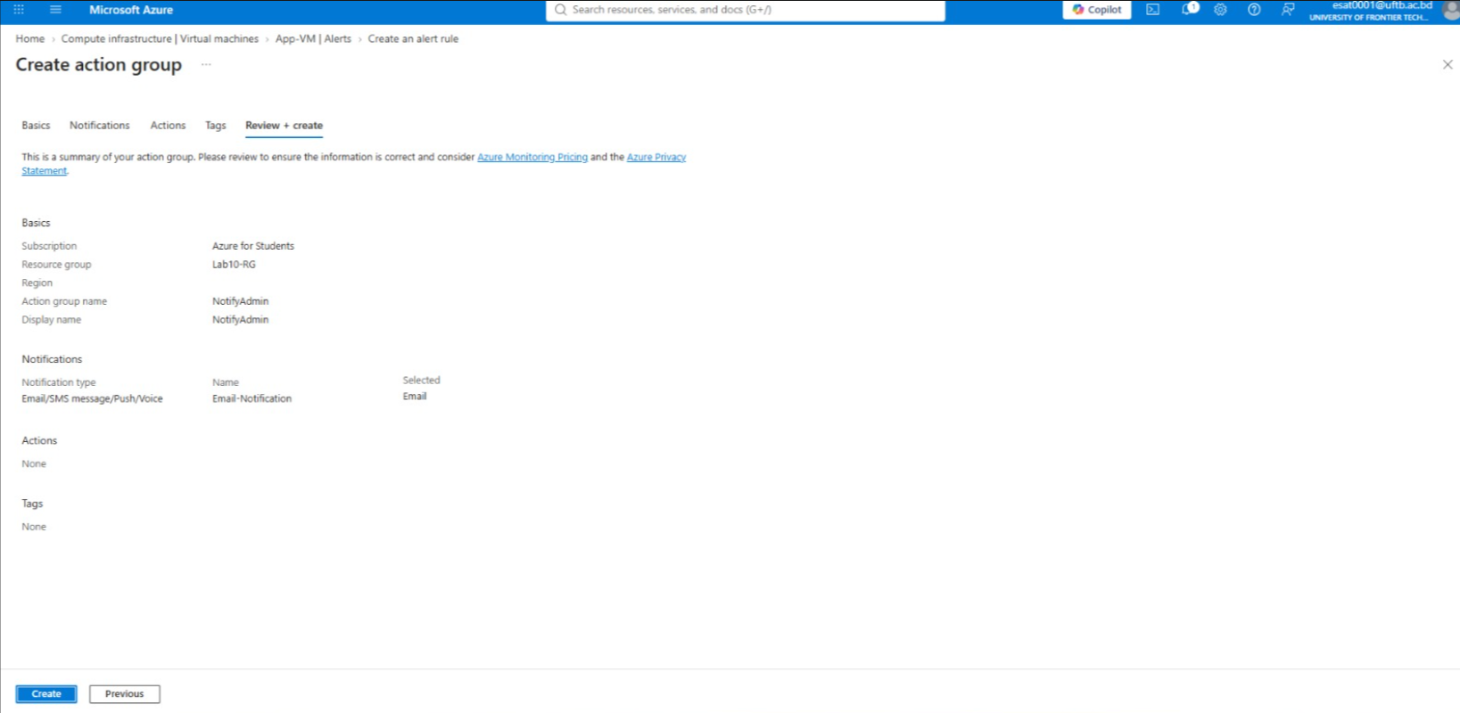
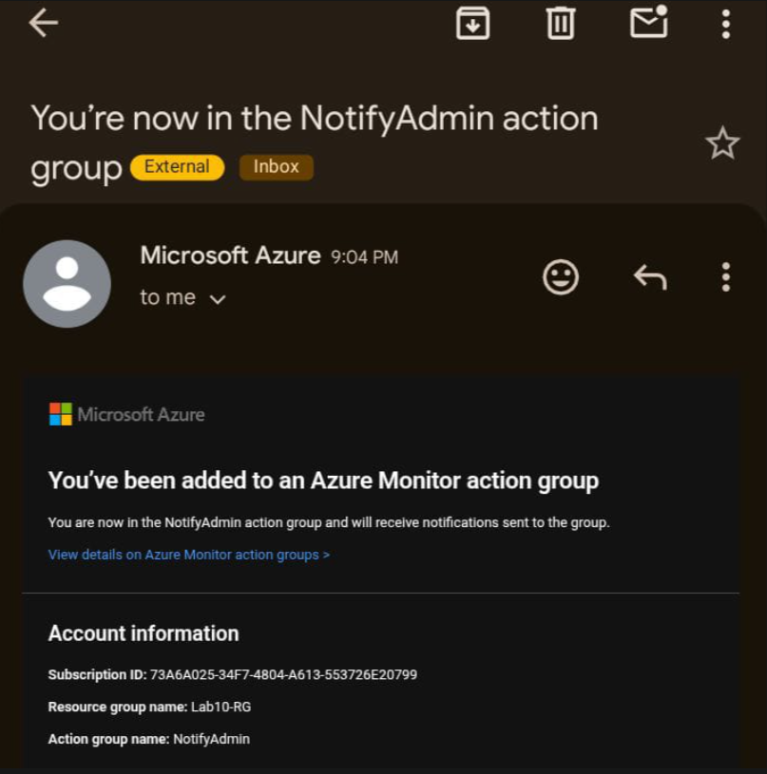

3.3 Cost Governance: Monthly Budgeting
To control operational expenditures and prevent unexpected credit exhaustion:
Scope | Lab10-RG / Subscription
Budget Name | Lab10-Monthly-Budget
Amount | $30.00 Monthly
Alert Trigger | Automated email notification dispatched when actual cost reaches 80% of the budgeted limit.

Cost Management Budgets dashboard showing Lab10-Monthly-Budget:
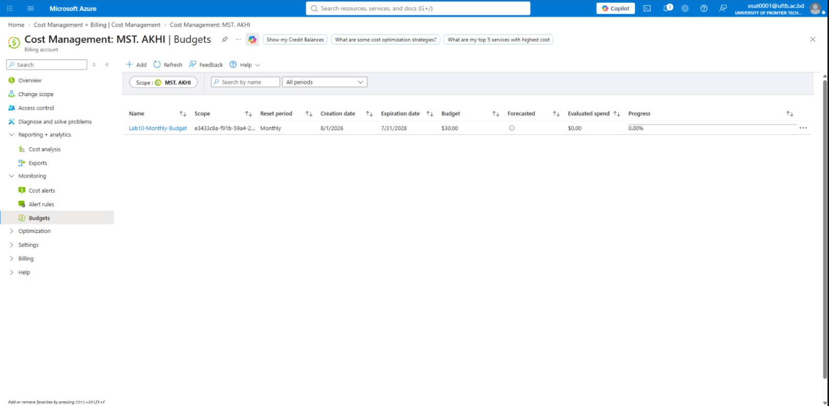

Total Lab Expenditure & Credit Analysis:
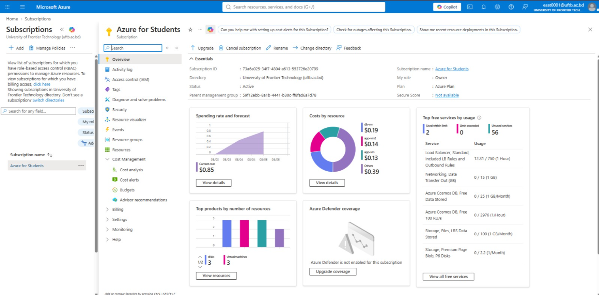
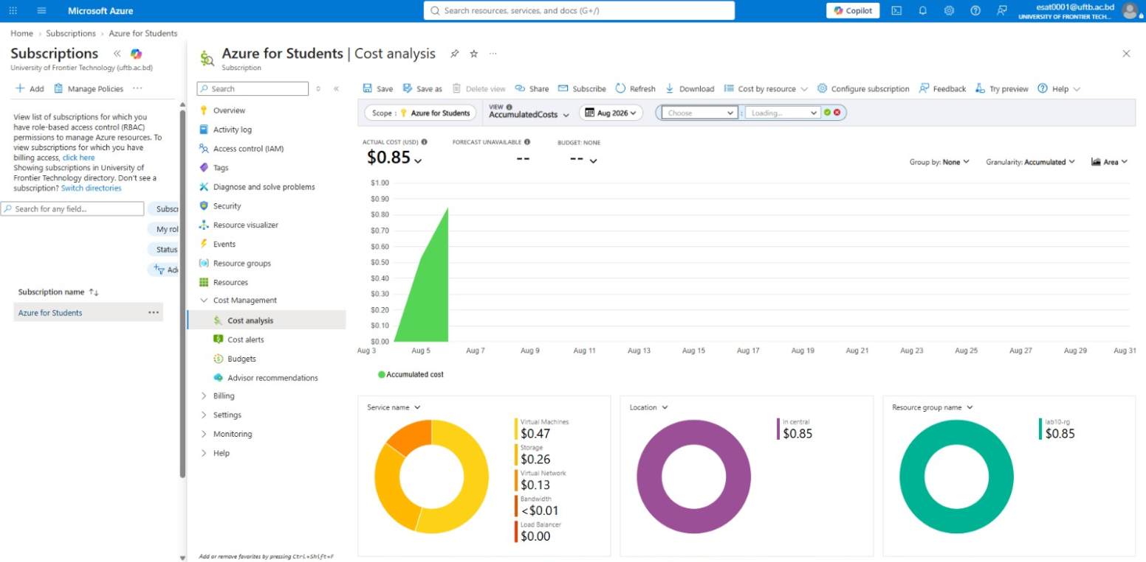
3.4 Analytical Questions & Technical Evaluation

Question 1: Compare metrics before and after enabling load balancing. What changed and why?
Before Load Balancing
All incoming traffic hit a single virtual machine instance. During peak traffic or stress testing, CPU utilization and network latency spiked significantly on that single node, creating a single point of failure (SPOF).
After Load Balancing
Traffic is distributed across two backend nodes (App-VM and App-VM2). Individual node CPU utilization decreased, network load was balanced, and system reliability improved. In the event of a single node failure, failover occurs instantly without disrupting service continuity.

Question 2: Identify which resources incur the highest cost and suggest optimization strategies.
Highest Cost Resources
- Virtual Machines (Compute - D-Series): Compute resources running 24/7 account for the primary share of infrastructure spend.
- Standard Public IP Addresses: Provisioning static/standard public IPs for Load Balancers and VMs incurs fixed hourly charges.
Optimization Strategies
- Auto-Scaling / Scheduled Shutdowns: Implement auto-scaling or Azure Automation runbooks to stop/deallocate non-production instances outside business hours.
- Instance Right-Sizing: Evaluate actual CPU usage and migrate from general-purpose D-series to B-series (Burstable) VMs for variable workloads.
- Azure Reserved Instances (RI): Commit to 1-year or 3-year Reserved VM Instances for production nodes to achieve up to 72% cost savings over pay-as-you-go pricing.

Conclusion
The deployment successfully met all design requirements:
- Network isolation was enforced via NSG rules, protecting the database tier from public exposure.
- High availability and automatic failover were established through Azure Load Balancer and Health Probes.
- Full operational transparency and financial governance were implemented using Azure Monitor alerts and Cost Management budgets.

